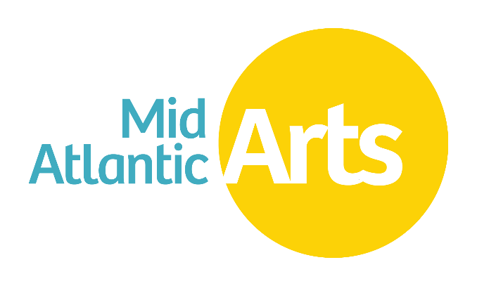
Jazz Touring Network
2024-2025 Membership Guidelines
Deadline:
August 31, 2023, 5:00 PM EST

ACCESSIBILITY
This publication is available in .PDF format and as an accessible Word file at www.midatlanticarts.org.

OVERVIEW
Jazz has a particularly rich history and thriving presence in the mid-Atlantic region. The marketplace for the presentation of jazz has evolved in recent years as the number of commercial jazz venues has declined and jazz artists have begun to turn to nonprofit presenting organizations and other alternative venues to sustain their ability to tour. To facilitate this shift in the touring environment and bring jazz to new audiences across the region, especially outside of its major metropolitan areas, Mid Atlantic Arts created the Jazz Touring Network (“JTN”).

Established in 2001, the JTN is a presenter-based membership program that provides support for professional development opportunities and performance fee grants for its participants. New members are selected on an annual basis through an open, competitive selection process. Membership criteria for JTN prioritizes performing arts presenters in the mid-Atlantic region with little or no experience in presenting jazz, while also encouraging applications from experienced jazz presenters seeking to strengthen their programming. The JTN prioritizes participation by presenters that work in and with communities underserved by the arts (defined for the purposes of this program as populations whose opportunities to experience the arts are limited by geography, ethnicity, age, economics, or disability). Once selected, membership in the program is ongoing contingent upon meeting annual participation requirements.
The underlying premise of the program is that by supporting nonprofit presenting organizations through professional development, experiential learning, and fostering collaborative relationships, JTN participants will have the skills and connections necessary to regularly and successfully present jazz in their communities as well as insure the vibrancy of jazz across the region. Since its founding, more than 50 presenting organizations have participated in the program. A list of the current JTN membership can be found on the Mid Atlantic Arts website at www.midatlanticarts.org.

GOALS AND OBJECTIVES
The goal of the program is to expand the presentation of jazz throughout the mid-Atlantic region while ensuring regional programming reflects the vibrancy and diversity of the current field of jazz. To achieve those goals the JTN has the following objectives:

- to maintain and grow an active, dynamic, and functional network of jazz presenters within the mid-Atlantic region
- for presenters to develop and share best practices that address current trends in the field and increase presenters’ capacity to program jazz at their organizations
- encourage members to annually curate tours that reflect the diversity and richness of the current field of jazz
- to deepen the audience and communities’ understanding and experience of jazz through thoughtfully planned performances and community engagement activities

ADMINISTRATION
Mid Atlantic Arts administers the JTN membership application process including application submission, review, and new member approval. Additionally, Mid Atlantic Arts coordinates an Annual JTN meeting attended by all members, facilitates the artist nomination and selection process, and ensures current members maintain eligibility by meeting membership requirements.

JTN TOURS
Members of the network collaboratively develop JTN tours through a nomination and voting process. Mid Atlantic Arts provides performance fee grants to JTN members for engagements that are part of block-booked tours. Selected tours must consist of a minimum of three presenters from, at least, two different jurisdictions within the mid-Atlantic region. Funded engagements must include at least one public performance as well as a community engagement activity. Community engagement activities are intended to create a deeper appreciation for the performance, the artist and/or the genre of jazz and provide additional opportunities for direct interaction with the visiting artists.

MEMBERSHIP REQUIREMENTS
To maintain membership in the JTN, presenters must designate a JTN representative with the authority to select and book artist on behalf of the organization and annually fulfill the following requirements:
- attend the JTN Annual Meeting in full;
- submit at least 1 artist nomination for consideration; and
- participate in at least one network block-booked tour.

MEMBERSHIP BENEFITS
The following financial support is annually available to all JTN members:
- performance grants up to $3,000 not to exceed 50% of the fee for any given engagement;
- a travel grant covering the majority of expenses related to attendance at the Annual JTN Meeting; and
- valuable professional development and networking opportunities.
Additionally, JTN members who act as “lead” presenters in developing tours receive an additional $100 for each network colleague participating in a tour. Lead presenter subsidies may not exceed $400 per member per year.

GRANT PAYMENTS AND REPORTING
Performance grants available to JTN Members are for engagements occurring during the period July 1 through June 30 of the given program year. The initial payment of 90% of the grant will be released when the following items have been completed by the grant recipient:
- review and execution of a grant award agreement,
- provide a copy of the countered-signed contract with the proposed artist to Mid Atlantic Arts no later than 30 days prior to the engagement start date.
A final report for a funded engagement is to be completed through Mid Atlantic Arts’ grant portal and is due no later than 30 days after the project completion date. The final report, made available in the grant portal at the time the grant is awarded, requires brief description of the completed project along with an accounting of expenditures of the funded activities. Final report instructions are provided as part of the grant award documents.

APPLICANT ELIGIBILITY
Mid Atlantic Arts accepts JTN Membership Applications from presenters within the mid-Atlantic region. For the purposes of this program, Mid Atlantic Arts defines a presenter as an organization that selects and engages professional touring artists to perform before general audiences in its community and manages the logistics in connection with those performances as an ongoing and significant component of their organization’s activity. Presenters manage all the local requirements for the performance and facilitate the interaction between artists and the public.

The JTN welcomes presenters that have little or no experience presenting jazz or experienced jazz presenters that have the desire to expand or enhance their programming.

Applicants must:
- be located in Delaware, District of Columbia, Maryland, New Jersey, New York, Pennsylvania, Puerto Rico, the U.S. Virgin Islands, Virginia, and West Virginia;
- be designated by the United States Internal Revenue Service as a 501(c)(3) nonprofit organization or be a unit of state or local government; and
- be in good standing with Mid Atlantic Arts, with no overdue or outstanding required reports and/or grant documents.
- have, at least, a three-year continuous history of offering multiple presentations by touring artists each season.
In addition to being committed to supporting diverse, equitable, inclusive, and accessible programming in our region, Mid Atlantic Arts strives to achieve balanced Network membership by offering priority consideration this year for organizations that:
- are located in Delaware, New Jersey, Puerto Rico, US Virgin Islands, and West Virginia.
- are not directly affiliated with a college or university
- are located outside of a major metropolitan area

WHO MAY NOT APPLY
- Presenters that are commercial or for-profit entities
- Presenters that primarily serve and market to K-12 schools, summer camps, nursing homes, senior centers, healthcare facilities, social service agencies, or solely student-based college or university programs

HOW TO APPLY & REQUIRED APPLICATION MATERIALS
All applicants must submit an online application through Mid Atlantic Arts’ grant portal at https://midatlanticarts.smartsimple.com/. You must create an account and login to access the Jazz Touring Network member application.
Applicants must complete the following:
  - Applicant Information
  - Presenting Profile
  - Budget Summary
  - Application Narrative
  - Statistical Information
  - Certification

DEADLINE
5:00 PM EST on THURSDAY, August 31, 2023
All JTN membership applications must be successfully submitted by that time. No exceptions will be made to the deadline.

MEMBER SELECTION PROCESS
JTN membership applications are evaluated by a panel comprised of jazz professionals and presenters. The applications will be ranked based the applicants’ ability to demonstrate the following:
- programmatic merit - the organization’s commitment to holistic programming directly aligned with their mission and demonstrated by a presenting history that reflects strong artistic merit, artistic excellence, and a deep awareness of audience and community;
- level of interest in growing the organization’s jazz presenting -or- demonstrated need to improve one or more aspects of current jazz presenting;
- ability to annually participate in JTN Tours and sustain high-quality jazz presenting as demonstrated by a combination of the organizations’ capacity, mission, and identified JTN Representative;
- potential to reach communities underserved by the arts (populations whose opportunities to experience the arts are limited by geography, ethnicity, age, economics, or disability);

- proximity to priority jurisdictions (Delaware, New Jersey, Puerto Rico, US Virgin Islands, and West Virginia).
Applicants will be assessed in part on the risk of noncompliance with Federal statutes, regulations and the terms and conditions as provided by the applicant’s Certification and Statement of Assurances in the submitted application or Common Information Form and the results of previous audits including adherence to Single Audit requirements as set forth by Federal statutes.

NOTIFICATION
All applicants will be notified in writing of Mid Atlantic Arts’ decision by late-September 2023. The decisions of the Mid Atlantic Arts are final and may not be appealed.

CONTACTING MID ATLANTIC ARTS
If you have reviewed the available resources and need assistance, or have questions pertaining to the program guideline requirements, please contact:
Ernest Stuart
Program Director, Jazz
Mid Atlantic Arts
estuart@midatlanticarts.org
410-539-6656 x116

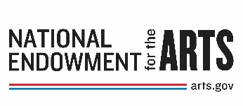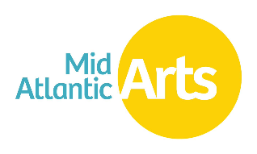
The Jazz Touring Network is made possible through the generous support from the National Endowment for the Arts’ Regional Engagement Program.23

