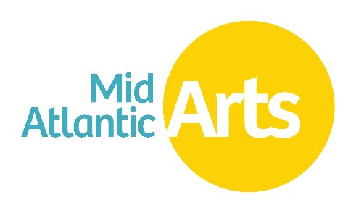

USArtists International Work Sample Preparation Guide

Panelists review many work samples in a short timeframe. Help them to review your work samples with ease:

Work Sample Submission:
- Is it a needle in a haystack? In the Work Sample portion of the application, applicants submit work samples via a link/web address/URL to their video or audio samples. These links should go directly to a specific sample, and not to a folder containing multiple recordings or videos.
- Is it queued up? The application requires two work samples that are each no more than ten minutes in length. The link/URL you submit for the work sample should take panelists directly to the point in the video you wish them to start viewing. Cueing to timestamps via URL is expected. Here are instructions on how to do this for videos posted to YouTube, Vimeo, and Google Drive. Panelists review each work sample to the extent required to evaluate the work. Work samples may not be viewed in their entirety.
- Is it accessible? It is the applicant’s responsibility to ensure links remain public and accessible during the review period. Double check permission settings on links, and test them before submitting. If the work sample must be password protected, provide the password for panelists to access it.

Tips for Work Sample Selection:
- Is it relevant to the application? If possible, include samples of the work to be performed at the proposed engagements.
- How do the samples connect to the engagement? Use the work sample description fields in the application to describe how your work samples connect to your proposed activity. This can be especially helpful if you do not have a sample of the work to be performed at the proposed engagement.
- Who is featured? If the performers in the work sample and those going to the proposed engagement are not the same, please include a brief explanation in your note about the work sample.
- Are they too similar? Since two work samples are required, it is helpful for panelists to see contrasting samples, or samples pulled from two separate pieces of work.
- Is it heavily edited? Work samples should not be short clips edited together to show every aspect of a performance, but rather uninterrupted selections that show what it would be like for an audience member attending your performance.
- Is it current? When possible, samples should not be more than three years old.
- Did you phone a friend? It can be helpful to get feedback from friends or colleagues before submitting work samples.
- Is it a promo? Mid Atlantic Arts will not accept the submission of marketing videos or sizzle reels as they do not provide an adequate representation of an artist/ensemble’s work.
- For dance or theater artist/ensembles, work samples must be videos and document a live performance. As heavy editing can detract from panelist viewing, it is discouraged.
- Does it show you at your best? Work samples should represent the work of the applicant and should be of the highest quality possible as panelists both familiar and unfamiliar with the artist/ensemble will be judging artistic excellence.
Additional Resources:
- For more great work sample tips, we recommend this article from Creative Capital.

