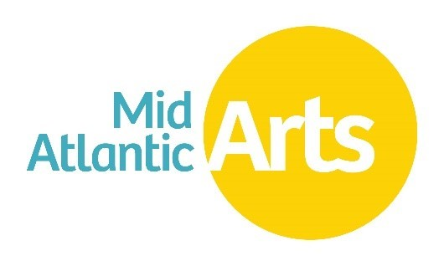
ArtsCONNECT | Projects in Development listing
Last updated: December 11, 2024
Projects in Development listing closes: February 13, 2025
Application deadline: February 25, 2025
Project Period: July 1, 2025- June 30, 2026

ACCESSIBILITY

To request accommodation during any phase of your application process, reach out to Program Director, Performing Arts and Accessibility Coordinator Sarah Lewitus at slewitus@midatlanticarts.org or call 410-539-6656 X 110.

ArtsCONNECT PROGRAM LINKS
- Review the ArtsCONNECT guidelines at this link
- Submit your ArtsCONNECT application at this link

PROJECTS IN DEVELOPMENT TABLE OF CONTENTS
Dance 1
Ephrat Asherie Dance with Arturo O'Farrill - New York, NY 1
Circus 2
Folk & Traditional 2
Multidisciplinary 2
Music 2
Warren Woolf, vibes & Bergamot String Quartet - Baltimore, MD 2
Puppetry 2
Theater 2

Dance

Ephrat Asherie Dance with Arturo O'Farrill - New York, NY
Dance
Web presence: https://www.pentacle.org
Proposed fee range: Greater than $10,000 USD
Brief description: Ephrat Asherie Dance collaborates with Grammy award-winning jazz musician and composer Arturo O’Farrill in the company’s newest creation, Shadow Cities. Bringing together EAD’s exhilarating choreography that remixes and reconnects various street and club dance styles with music and an original composition featuring O’Farrill’s trademark Latin jazz sound, Shadow Cities explores what it means to be and to feel in-between.
Other links:
http://www.pentacle.org/wp-content/uploads/2018/11/Copy-of-EphratAsherie_2018cDuggan_032-1.jpg
Presenter information:
Modlin Center for the Arts, University of Richmond
Paul Brohan
pbrohan@richmond.edu | 8042876012
Other presenter(s) interested in participating in this consortium: Penn Live Arts/Annenberg Center for the Performing Arts

Circus

Folk & Traditional

Multidisciplinary

Music

Warren Woolf, vibes & Bergamot String Quartet - Baltimore, MD
Music
Web presence: https://www.warrenwolf.com/
Proposed fee range: Less than or equal to $10,000 USD
Brief description: Warren has made ten recordings, most notably for Mack Ave Records. Warren is a member of the SFJAZZ Collective and Christian McBride & “Inside Straight”. Warren is a faculty member at the Peabody Conservatory of Music in Baltimore, MD & the San Francisco Conservatory of Music in San Francisco, CA. Bergamot Quartet is an NYC-based string quartet dedicated to the evolution of chamber music. They are sought-after interpreters of contemporary music who are expanding the definition of the string quartet genre by leveraging their skills as a classically trained ensemble with their enthusiasm for learning from and adapting to creative artists across a variety of genres.
Other links:
https://www.warrenwolf.com/media
Presenter information:
Community Concerts at Second
Christopher Shannon
info@cc2nd.org | 7656311338
Other presenter(s) interested in participating in this consortium:

Apollo's Fire (small ensemble) - Cleveland, OH
Music
Web presence: https://apollosfire.org/
Proposed fee range: Unknown at this time
Brief description: Apollo’s Fire is a GRAMMY®-winning ensemble. The period-instrument orchestra was founded by award-winning harpsichordist and conductor Jeannette Sorrell. Dedicated to the baroque ideal that music should evoke the various Affekts or passions in the listeners, Apollo’s Fire brings to life the music of the past for audiences of today. Note: Community Concerts will likely be presenting a small subgroup (3-7 members) of this ensemble featuring violinist Alan Choo.
Other links:
https://apollosfire.org/media/photo-gallery-apollos-fire/
Presenter information:
Community Concerts at Second
Christopher Shannon
info@cc2nd.org | 7656311338
Other presenter(s) interested in participating in this consortium:

Puppetry

Theater

